* Asynchronous  Plugin  -

1.  Plugin  has  maximum  time  limit  of  2 minutes .   Plugin  running asyncounously  will  get  timed  out  after  2  minutes  .

2. We  can  configure  plugin  to  Run as  (another ) user's  context  .

3.  Can not  accept  any  input  parameters  ,  by  default it  takes  only  details  from the  entity  using  IPluginExecutionContext.

 Custom workflow  :

1.  Assembly  does  not  have  maximum  time limit  .  It  is  preferred  when  consuming  external  webservices  in the  plugin  .

2. Can  not  configure  with  Run as  ( another) user's context .

3. Can  accept  input parameters  and  returns  out  put  parameter  to  workflow .

4.  Can  be  configured  to  run as  a  child  workflow  while  plugin  does  not  have  this  feature .

You cannot make an Asynchronous Plug-in on demand like the way we can do it in workflows.

For those of you who are new to CRM or just new to custom workflow activities, let me take a moment to explain them.  Custom workflow activities allow you to add different types of “steps” to the existing “Add Step” menu in the workflow designer.  For example, one of the options available to you in the “Add Step” menu currently on the workflow is “Send Email.”

[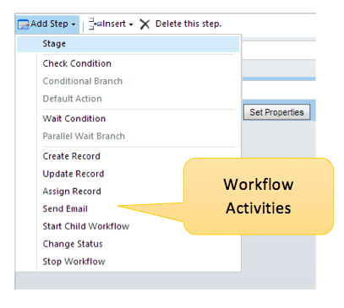](https://www.credera.com/wp-content/uploads/2014/08/Screen-Shot-2014-08-15-at-4.14.56-PM.png)  
By adding this step, you can create and send a dynamic email activity populated with data from the record which triggered the workflow. Custom workflow activities allow you to add additional functionality as steps of the workflow in the same way.

–  Have you ever needed to embed a link to a record inside the body of an email using a workflow?

–  Have you ever needed to format a DateTime property so it only showed the Date and not the Time?

–  Have you ever needed to add, subtract, multiply, or divide two numbers in order to create a calculated field?

If so, you are in luck. In this post, I’m going to explain how you would use custom workflow activities to add this functionality to your workflows.